Assignment - 3

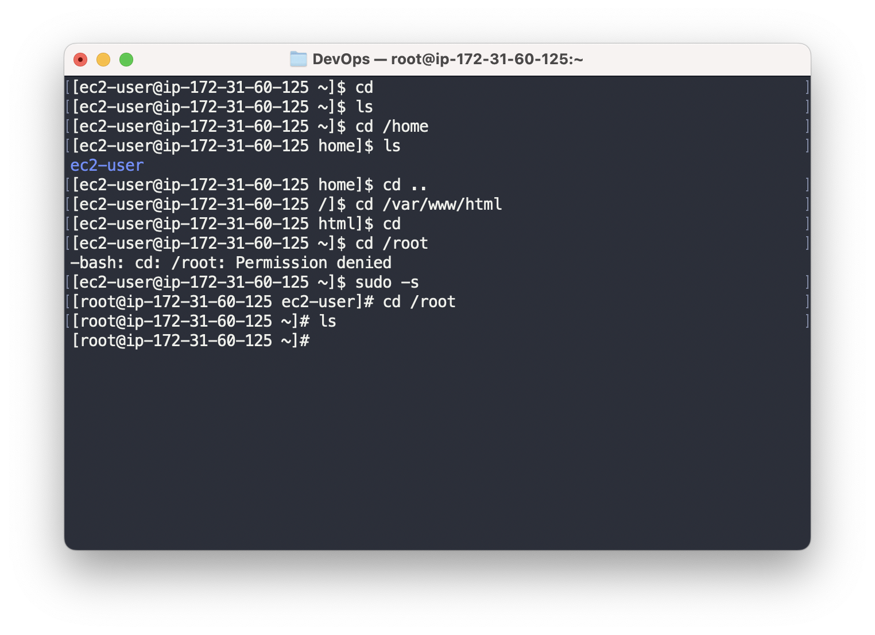

Assignment - 4

cd /etc  
It contains configuration files for the system and various installed applications. These files control the behavior of the system and applications and can be modified to change their behavior.  
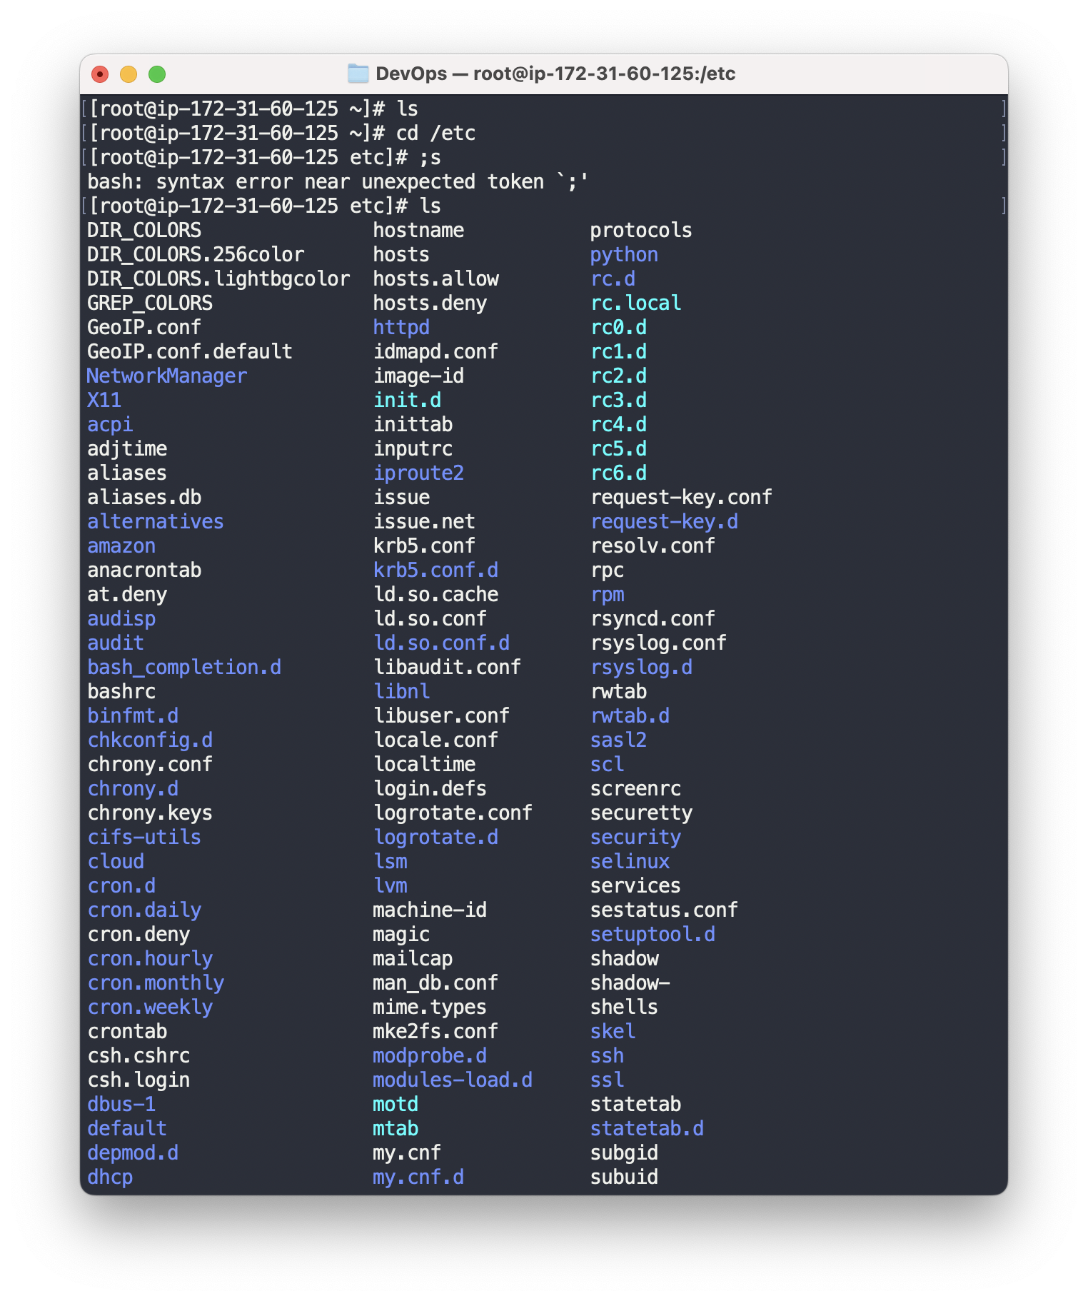

ls -al  
I’m seeing a list of all files and directories in the current working directory, including hidden files. The output will be displayed in the long format, which includes information such as the file permissions, owner, group, size, and last modification time for each file or directory.

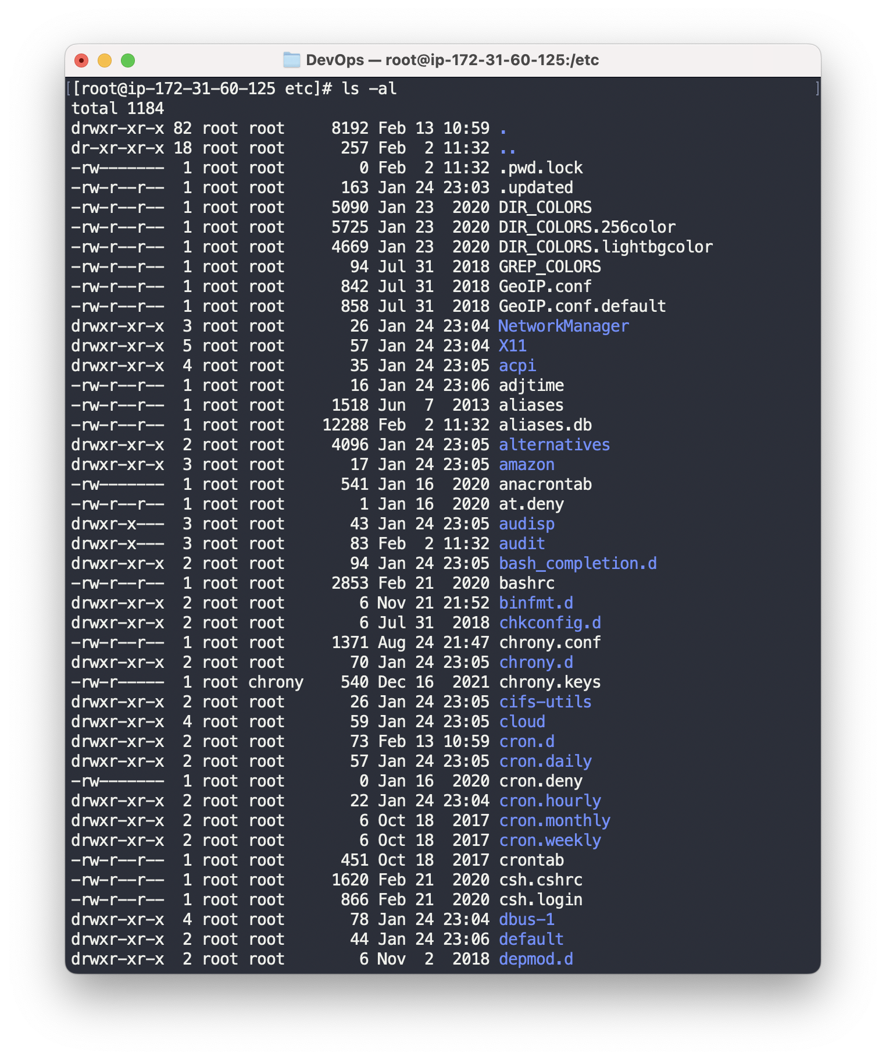

ls -i  
The -i option causes the ls command to display the inode number of each file and directory in the list. Inode (short for index node) is a data structure used by the file system to store information about a file or directory. It contains information such as ownership, permissions, timestamps, and the location of the actual data stored on the disk. When you run the command ls -i, you will see a list of all files and directories in the current working directory, along with their corresponding inode numbers.

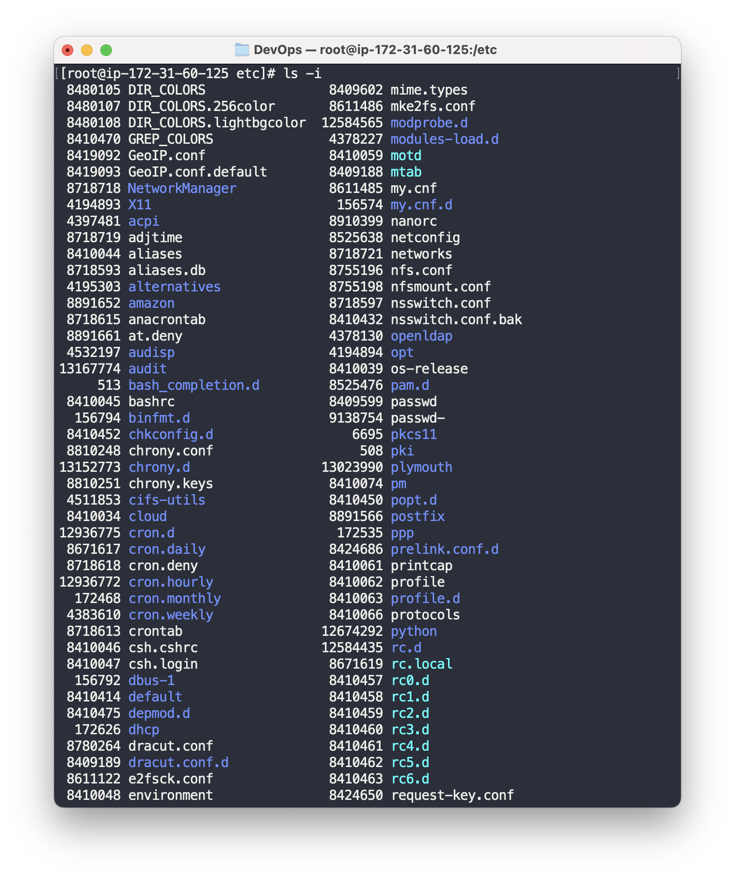

ls –help  
I’m seeing a list of all available options and a brief description of what each option does.  
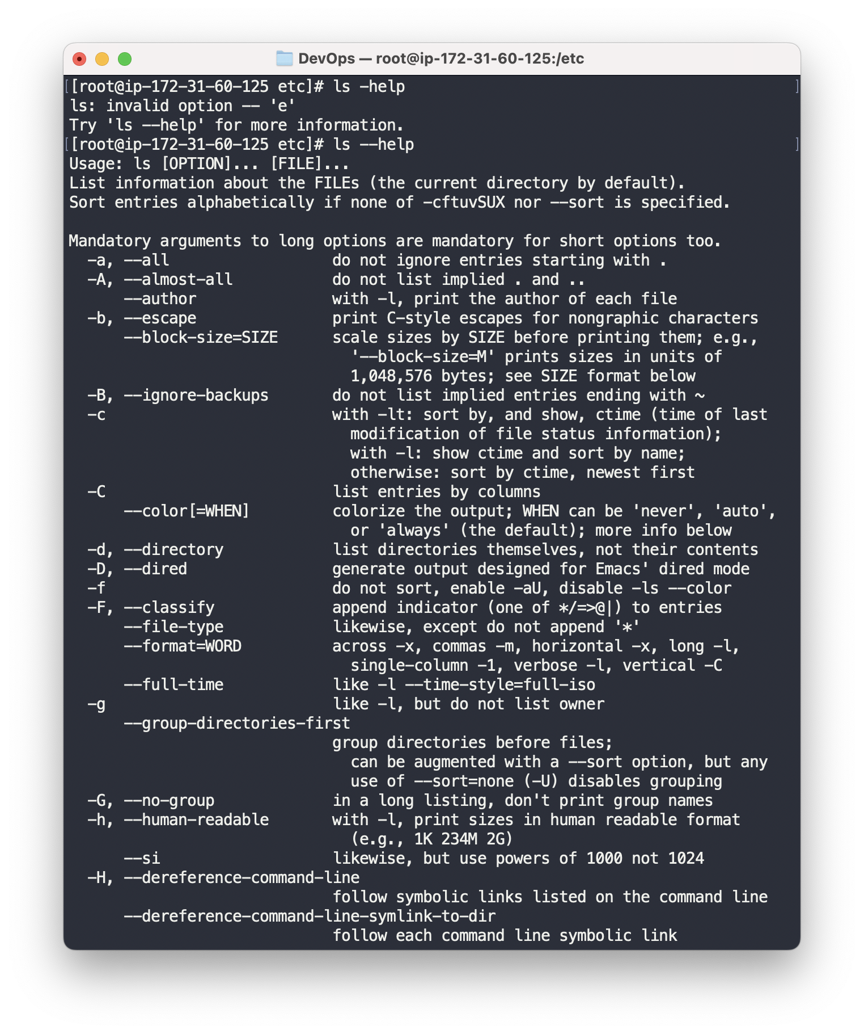

Assignment - 5  
